Computer Systems and Networks Project.

Student: TJ Fitzpatrick

Student Number: 20027865

Lecturer: Frank Walsh.

Course: H.Dip in Computer Science.

**Contents**

**1.** **Introduction.** 3

**2.** **Block Diagram.** 3

**3.** **Research.** 3

**3.1** **Button Tests.** 3

**3.2** **Serial Port Test.** 4

**3.3** **Capacitive Soil Moisture Sensor Test.** 4

**3.4** **Relay Test.** 9

**3.5** **Water Pump Test.** 9

**3.6** **Pi Communication Tests to Arduino.** 10

**3.7** **Pi Communication Tests to Blynk Website.** 11

**4.** **Design Methods.** 11

**5.** **Design.** 11

**6.** **Conclusion.** 11

# **Introduction.**

The purpose of this project was to demonstrate the capabilities of the MQTT protocol, and to gain a better understanding of the issues and challenges of a connected world (IOT Infrastructure).

# **Block Diagram.**

The following Block Diagram was how I broke this project down into different individual sections.

# **Research.**

## **Button Tests.**

This simple circuit is to test a button, the button is pressed the LED will light, and a logic 1 value will print up to the serial port, when the button is not pressed a logic 0 is printed to the serial port.

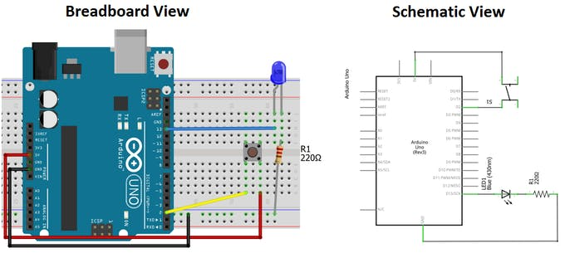

**Figure 1 - Arduino Button Test.**

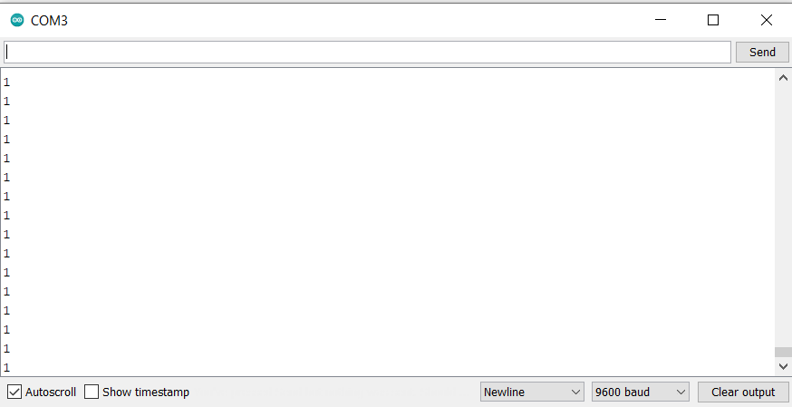

**Figure 2 -Serial Port Button Test.**

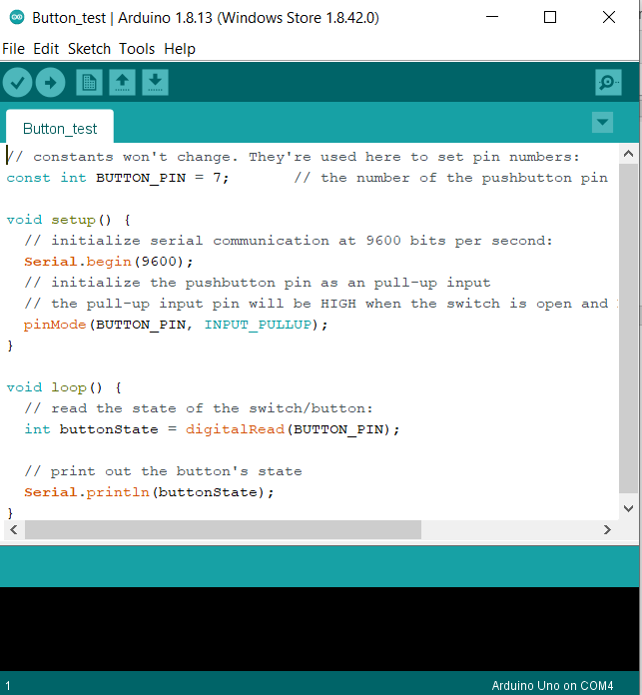

**Figure 3 - Button Test Code**

## **Serial Port Test.**

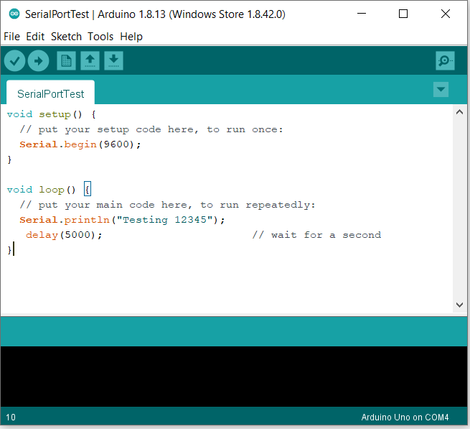

**Figure 4 - Serial Test Code.**

## 

## **Capacitive Soil Moisture Sensor Test.**

This sensor is placed inside soil up to each grove on each side, it then sends back an analogue value based on how moist the soil is.

This soil moisture sensor measures soil moisture levels by capacitive sensing rather than resistive sensing like other sensors on the market. It is made of corrosion resistant material which gives it an excellent service life.

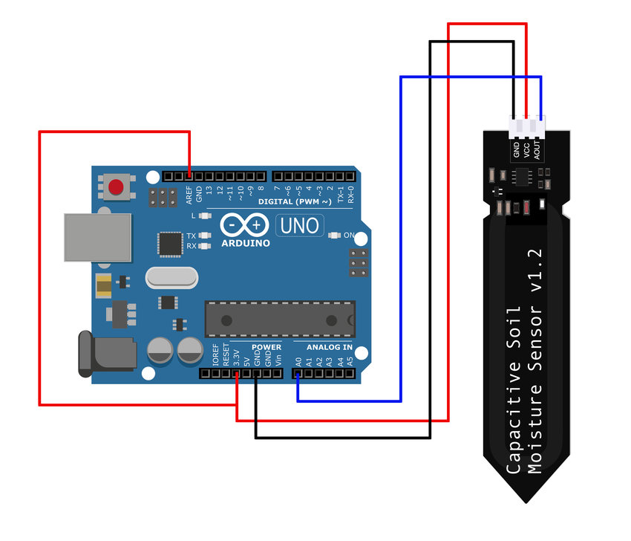

**Figure 5 -Capacitive Sensor Module.**

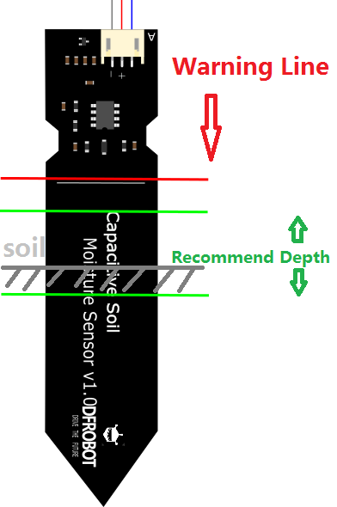

**Figure 6 - Recommended Soil Depth.**

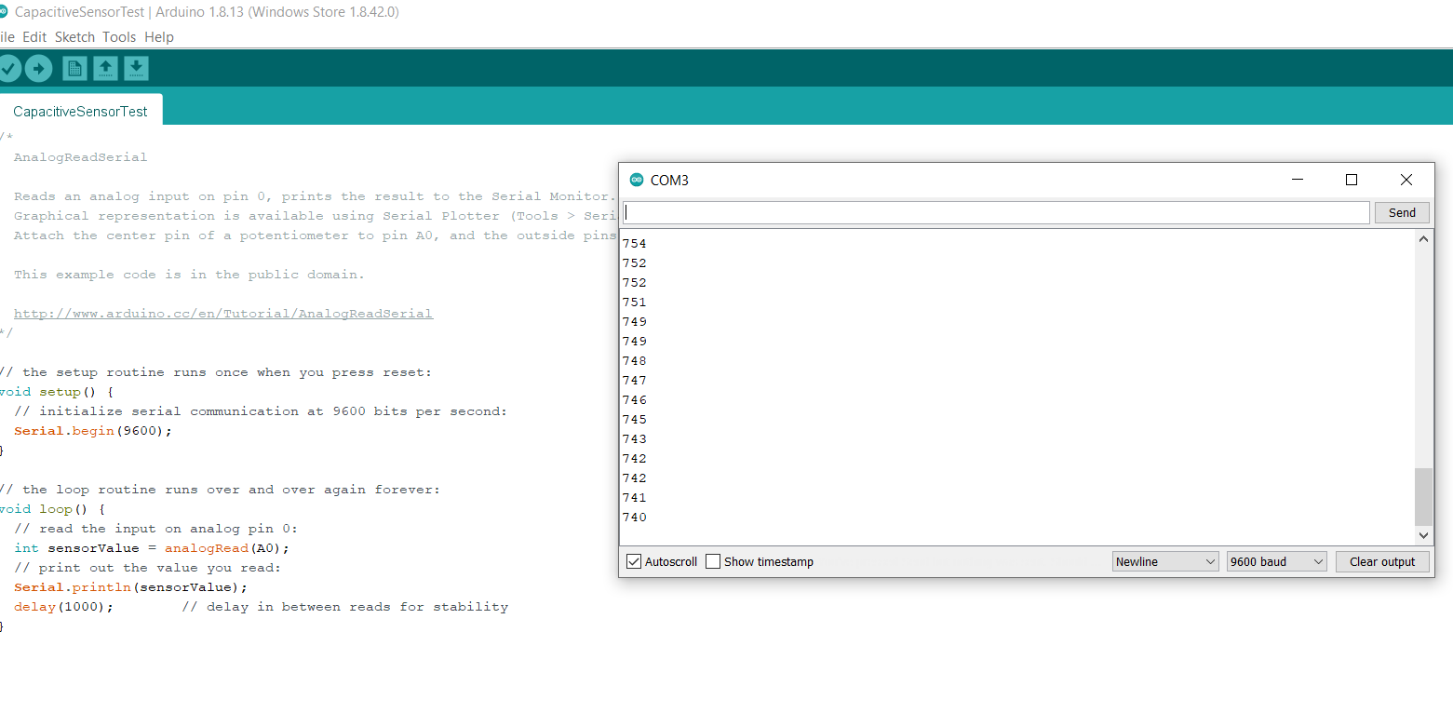

**Figure 7 - Arduino Comm Port Reading Soil Module.**

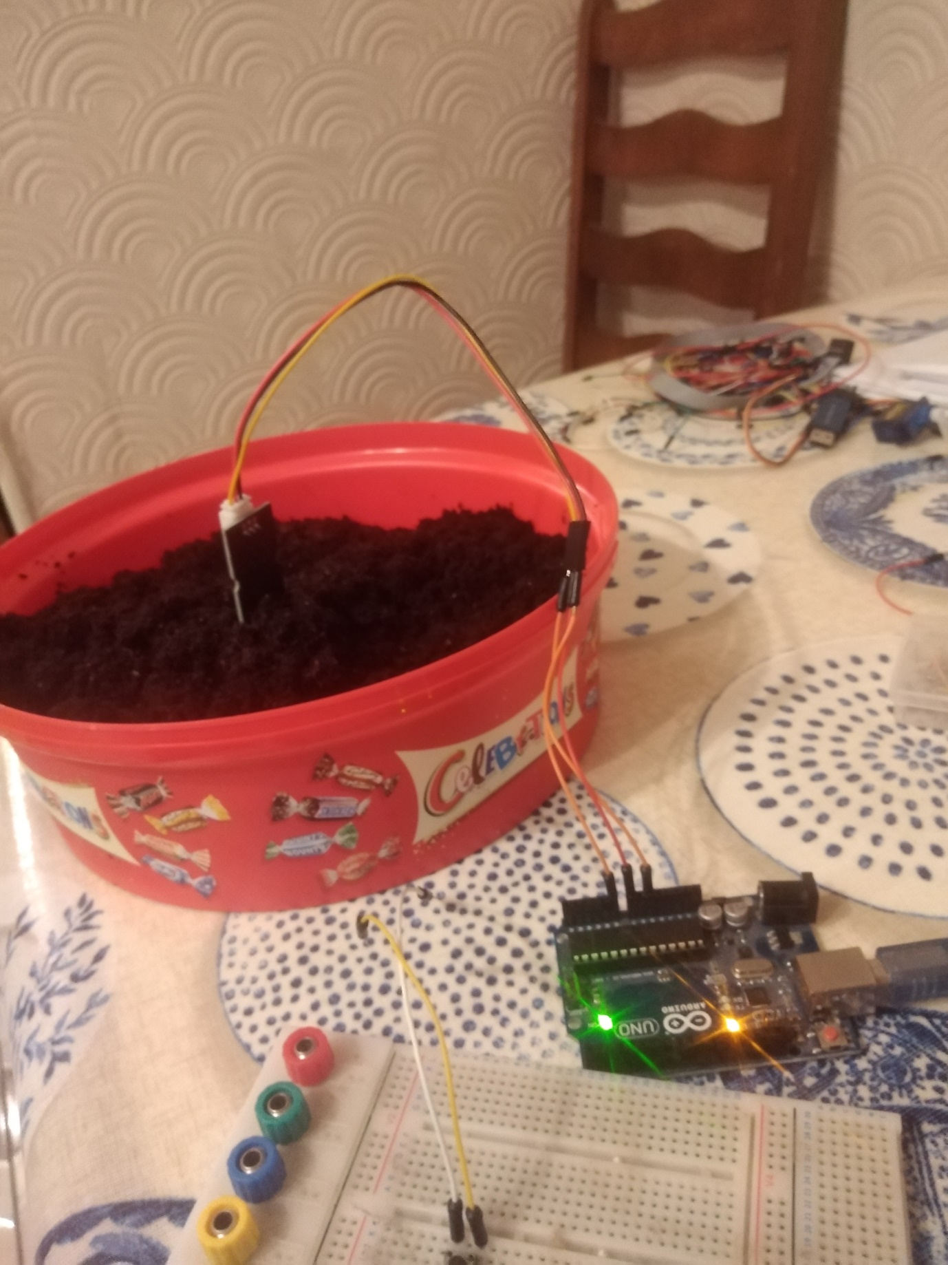

**Figure 8 - Actual Image of Soil Module.**

## **Relay Test.**

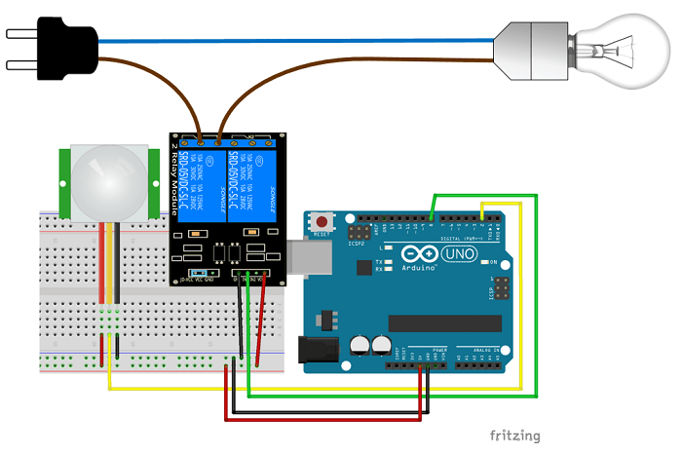

**Figure 9 – Arduino Relay Module.**

In my case I replaced a bulb with an LED and I turned it on and off.

## **Water Pump Test.**

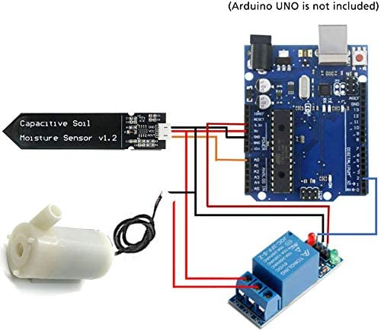

**Figure 10 - Water Pump Configuration.**

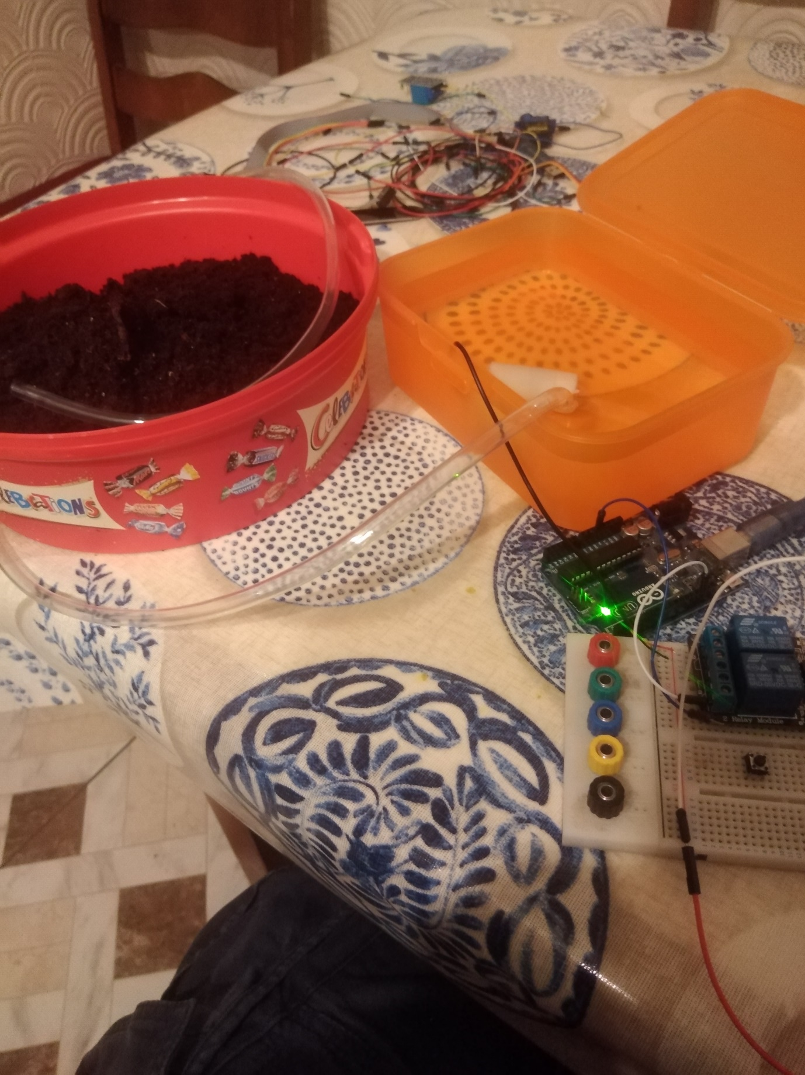

## **Pi Communication Tests to Arduino.**

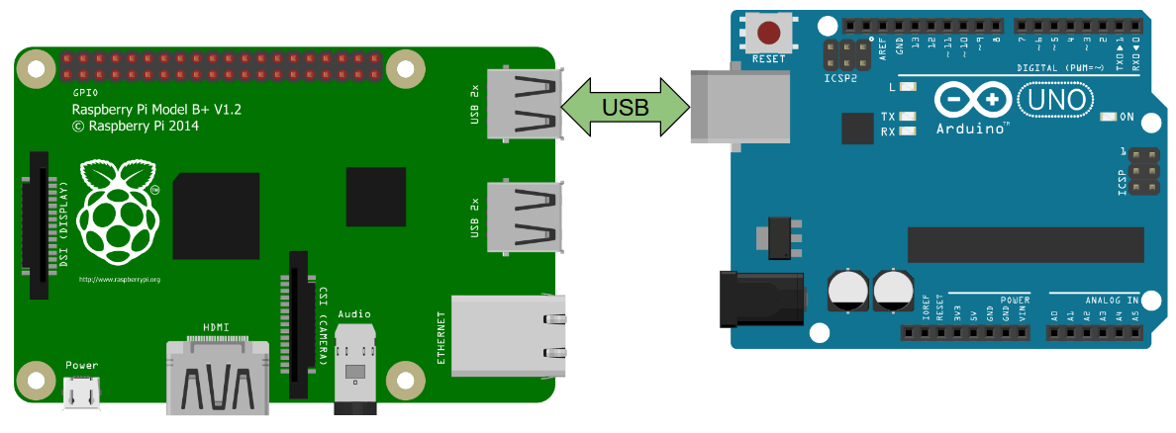

**Figure 11 - Arduino to Raspberry Pi Serial Communication**

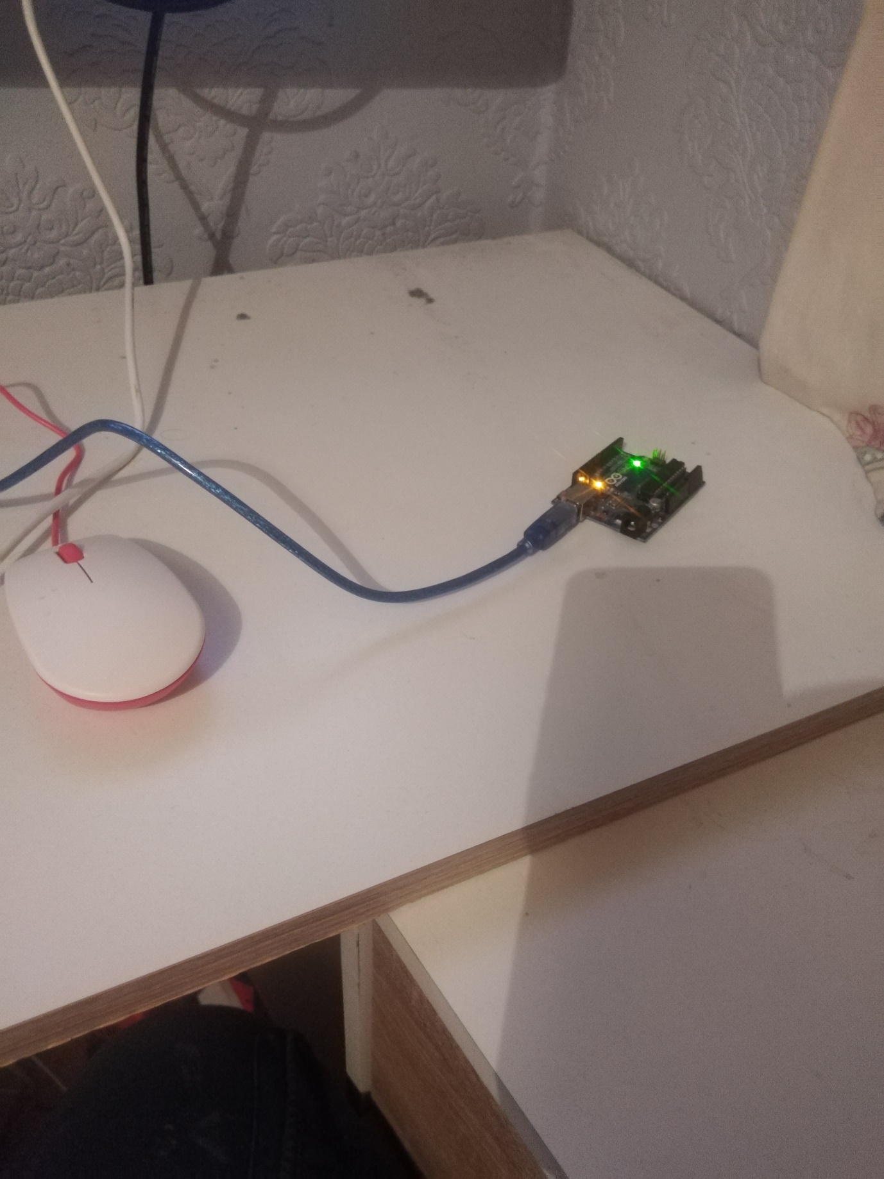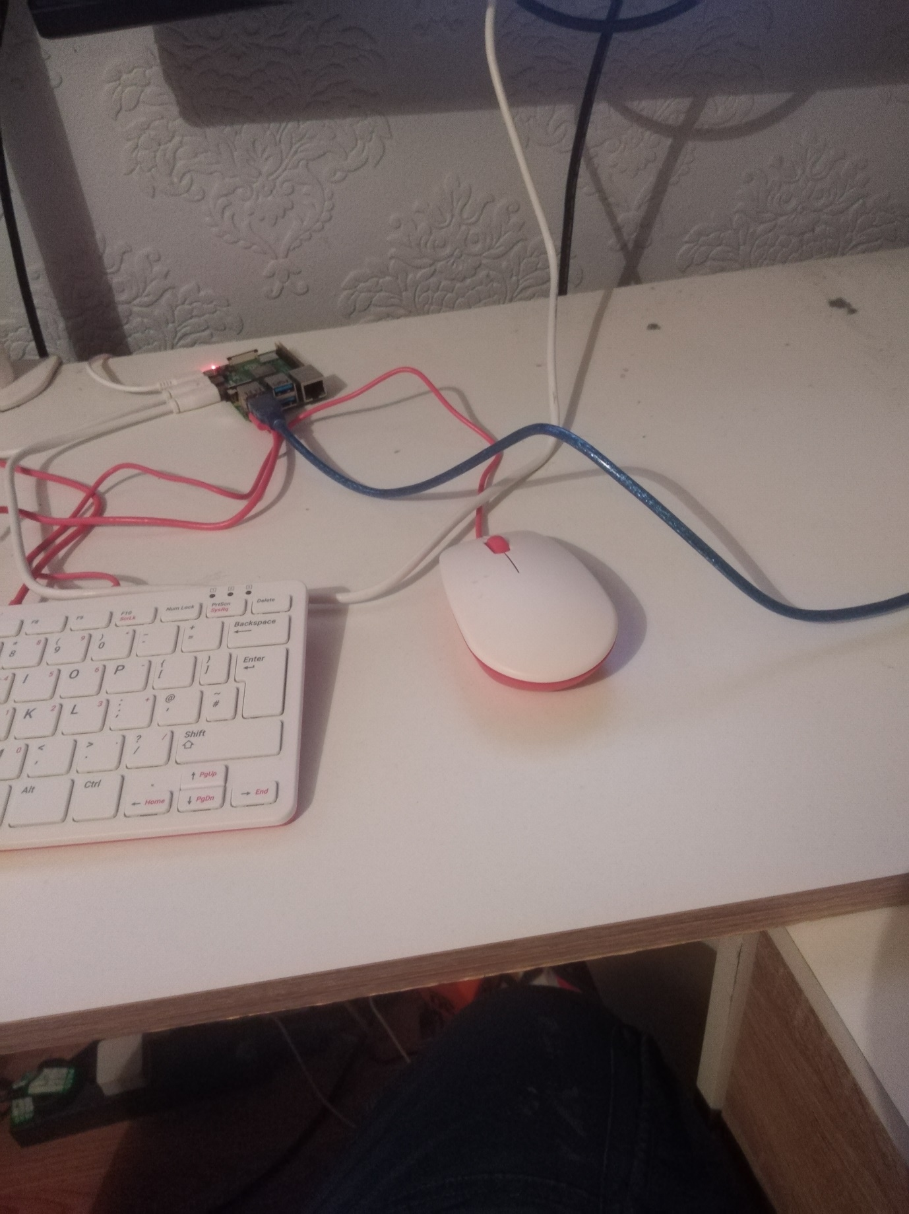

**Figure 12 - Arduino And Raspberry Pi Attached Serially Over USB.**

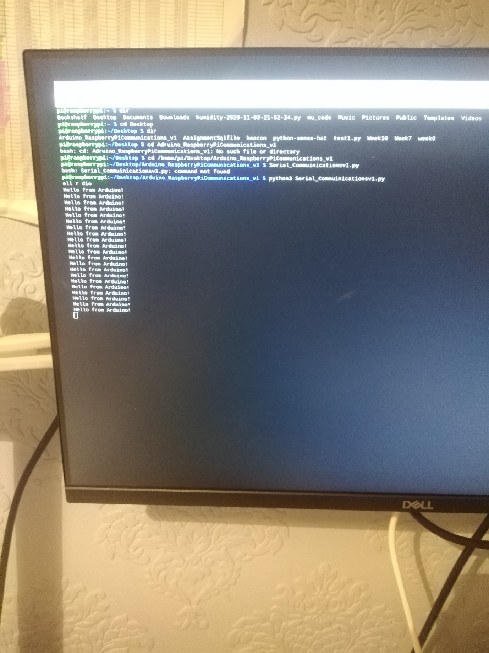

**Figure 13 - Hello From Arduino.**

## **Pi Communication Tests to Blynk Website.**

# **Design Methods.**

# **Design.**

# **Conclusion.**